Thermal Oxidizer Model
User Manual

Contents

- Overview

- Usage
- Input
- Valid input values
- Using default values
- Using direct Input
- Using input file
- Clearing all fields
B. Running the model
i. How to Run
ii. Cancelling a Run

III. Outputs
A. Outlet Concentration table
B. Profiles
C. Output Folder
- Input text file
- Input screenshot
- Excel output file

IV. Troubleshooting
- Error Messages

V. About

I. Overview
This application chemically models a thermal oxidizer with two air injection sites with the possibility of option of an aqueous ammonia injection for further NO_{x} removal. Users may configure the concentration of input species as well as certain specifications of the thermal oxidizer to their liking and obtain an output including CO, NO_{x}, and temperature profiles, and the concentration for species of interest at points throughout the length of the oxidizer.

II. Usage
- Input
i. Valid input values
This application requires the user to input valid numerical values. Valid values include positive integers (0, 1, 2, ...), numbers in scientific notation designated using a lowercase or uppercase E (e.g. 8*10^3 designated as 8e3 or 8E3).
Values may NOT include letters (except e or E used for scientific notation) or special characters (except a period to indicate decimal value).
ii. Using default values
The sure can use default values built into the program by using the “Set Default Values” button, selecting Edit->Set default values, or using the Control+D shortcut.
iii. Using direct input
The user can input values directly on the GUI by filling out all the white/modifiable (i.e. fields that are not greyed out) fields.
iv. Using input file
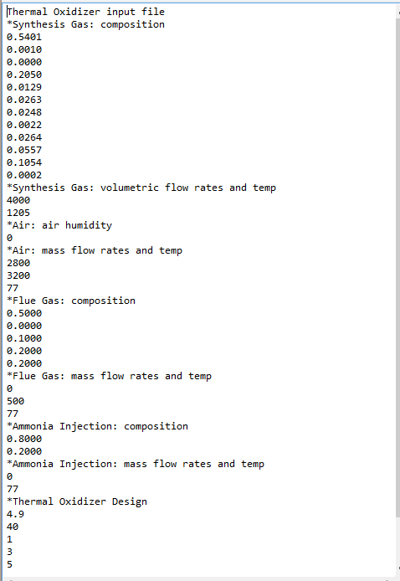
An text file (.txt) may be used to import values into the GUI; the user can do this by selecting File->Open Input file or using the Control+O shortcut. This input file must have a format like the sample input file in Figure 1. This file has several dividing text lines (i.e. dividers) that must be present in order for the input file to be valid. These include the first line and any other lines that begin with an asterisk (*); these indicate to the program where in the GUI to place the values. Dividers must contain the asterisk at the beginning, followed by the text shown; letters may be uppercase or lowercase as long as the words are spelled as indicated.

Figure 1: Sample Input Text File

*** Note: these dividers do not indicate to the program the order of the values
It is necessary that the user knows the order that the input fields occur in the GUI, as the input file does not have a way to distinguish which values belongs to which species; instead it follows a particular order of assigning the values. Figure 2 shows the order that the input file populates the GUI, which is designated by the blue line in the direction of the red arrows. You’ll notice that there are more fields in the GUI that there are in the input file, that is because the user only includes in the input file those fields that are not grayed out (i.e. modifiable) in the GUI.

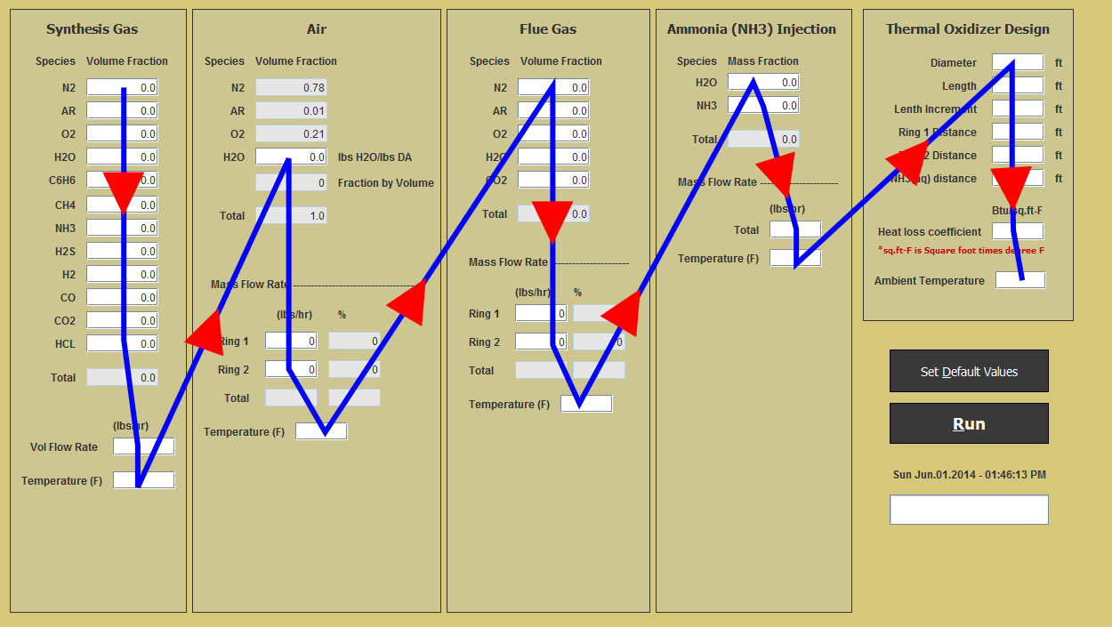
Figure 2: Sample image demonstrating order in which input file fills GUI
For further reference, the order the GUI is filled out is as follows, this is the order in which inputs in the input text file should appear:
- Synthesis gas:
1) N2
2) AR
3) O2
4) H20
5) C6h6
6) CH4
7) NH3
8) H2S
9) H2
10) CO
11) CO2
12) HCL
13) volumetric flow rate
14) temperature
- Air
- H20
- mass flow rate - ring 1
- mass flow rate - ring 2
- temperature
- Flue Gas
- N2
- AR
- O2
- H20
- CO2
6) mass flow rate - ring 1
7) mass flow rate - ring 2
8) temperature
- Ammonia Injection
- H20
- NH3
- Mass flow rate
- Temperature
- Thermal Oxidizer design
1) diameter
2) length
3) length increment
4) ring 1 distance
5) ring 2 distance
6) ammonia injection site distance
7) heat loss coefficient
8) ambient temperature
v. Clearing all fields
All fields may be “cleared” meaning that all fields are set to either “0” or empty, depending on which field it is. To do this the user can select Edit->Clear all fields or use the Control+Shift+D shortcut.

- Running the Model
i. How to Run
To run the model select the “Run” button in the GUI, select Run->Run, or use the Control+R shortcut.
Once selected the GUI may or may not display error or warning messages that either prevent the run from occuring or alert the user about a certain condition that is not met or ideal. For more information on these messages, refer to the Troubleshooting section.
ii. Cancelling a Run
A run can be cancelled anytime during execution by selecting Run->Cancel run or by using the Control+Shift+C shortcut.
*Note: an ouptut folder for that run will still be created, it will inlcude the input screenshot and input text file but not the excel output folder (for more on this refer to the Outputs section)

III. Outputs
- Outlet Concentration Table
- Profiles
- Output Folder
Each time the user runs the model (whether the run is completed or is cancelled) an output folder for that specific run is created in the Model Outputs folder in the application folder/directory. This output folder will contain at least the first two of the following outputs (the Excel output folder is not created if the run is not succesffully completed or is cancelled).
i. Input text file
A text file is created with the values used in the corresponding run. This file can also be used for reference or as an input for a future run.
ii. Input screenshot
In addition to a text file, a screenshot of the GUI is saved for any further reference to the input used in a certain run; this is only for better visual reference.
iii. Excel output file

IV. Troubleshooting

V. About

This model was developed as part of an effort to ....blah blah blah

The principal investigaor (P.I.) in this research is Dr. C. David Cooper of the University of Central Florida.
Software Developers: Luis Martinez and David L. Hernandez, students at the University of Central Florida.

